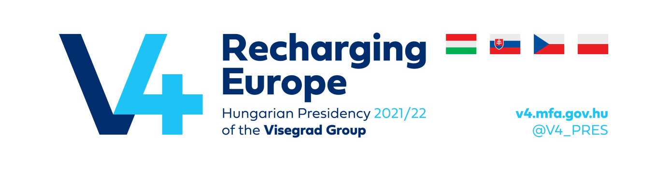
JOINT STATEMENT BY THE VISEGRAD GROUP STATES
ON SOME ELEMENTS OF THE PROPOSAL ON REVISION OF THE TRANS-EUROPEAN TRANSPORT NETWORK DEVELOPMENT
(Le Bourget, February 2022)
The Visegrad Group states (Czech Republic, Hungary, Republic of Poland, the Slovak Republic) present the following observation with regards to the Proposal for a Regulation of the European Parliament and of the Council on Union guidelines for the development of the transport network, amending Regulation (EU) 2021/1153 and Regulation (EU) No 913/2010 and repealing Regulation (EU) 1315/2013 (COM(2021) 812; 2021/0420 (COD)), published on 14th December 2021. This joint statement reinforces previous positions of the Visegrad Group already communicated in the context of the revision of the regulation on the trans-European transport network (TEN-T).
General observations
The Visegrad Group countries generally welcome the revision of the TEN-T Policy and the efforts to adjust legislation to better adapt the trans-European transport infrastructure to the changing market demand and to create the base for reliable, safe, resilient and sustainable mobility. Furthermore, we recognize the potential of the revision to boost closer cooperation among Member States, the European Commission, its coordinators and other institutions. This can benefit improved management of the TEN-T networks, with a special intention to reduce bottlenecks and complete the network sufficiently and in a reasonable manner. While the completion of the TEN-T core network by 2030 remains our key priority, we welcome addition of the extended core network. We see it as an important political signal to develop big infrastructure projects in the region of Central Europe, in particular high-speed railways and thus help us meet goals set out in in the European Green Deal policy and in the Sustainable and Smart Mobility Strategy. The further development of the TEN-T network by setting new deadlines and new parameters has to be accompanied by appropriate financial resources to secure their implementation beyond current funding period. A clear commitment from the European Commission side is required that CEF funding in the future will tackle the projects also on extended core TEN-T network as similar priority as projects on the TEN-T core network. We encourage the Commission to maintain a specific targeted allocation devoted to the significant cross-border rail projects between the Cohesion Countries in the next CEF III proposal.
TEN-T revision as regards the development of the railway infrastructure
The Visegrad Group countries recognize and welcome the extension of the TEN-T network by including new elements of future High-Speed Rail network which should create a connection through all V4 countries with a potential to connect broader Central Europe region. We especially welcome their inclusion into core or extended core TEN-T. We also welcome the integration of sections included in the Rail Freight Corridors (RFC), dominantly their main lines. While adding new requirements for this mode of transport (such as the P400 loading gauge, 740 m freight train length, 160 km/h minimum line speed for passenger transport), could generally contribute to better performance of the future TEN-T railway network, it also may hinder the efficient railway infrastructure development. As the railways are to play a key role in achieving the objectives of the EU sustainable transport policy it creates very high investment needs related to this transport mode. It is therefore a prerequisite to ensure sufficient funding at the European level. The proposed new standards not just increase the costs of the remaining required developments but also could require further interventions even on recently completed lines.
Regarding ERTMS, we support its implementation in the TEN-T network within the currently set deadlines, while implying step-by-step approach to secure safety and interoperability of the network.
The V4 calls to take into account the multi-actor nature of the requirement regarding border crossing waiting times. It goes far beyond the activity of rail infrastructure managers, relying very much also on procedures of (usually private) railway undertakings and especially on border- and custom related duties which are independent from multiannual contractual agreements between the Member States and the infrastructure managers contrary to the stipulations of the proposal.
Urban nodes and intermodal transport
V4 countries in general welcome the idea of strengthening urban layer of TEN-T policy. However, one should bear in mind that a significant extension of the list of urban nodes and linking this list to the necessity to build at least one freight and passenger terminal in each node will result in a substantial demand for financial resources. Sufficient EU funding and revised transport relevant EU State aid rules in this area are essential precondition to fulfil all new proposed requirements. We would also like to draw the European Commission’s attention that in case of both passenger transport (e.g. participation of municipal authorities) and freight terminals the fulfilment of this obligation may also result in competence and financial disputes since terminals mostly belong to the private sector. In the case of freight terminals, the current approach should therefore be maintained - a minimum of one terminal in each NUTS II region and additional terminals taking into account the reported minimum required performance.
The V4 countries also express doubts about the proposed requirement to report data on urban mobility, creating further reporting obligations generating costs and burden for the administration. Member States are not in the position to properly analyse the effects and to discuss the needs with the interested cities as long as the methodology for the data and its collection is not detailed.
The V4 countries appreciate the positive role of Sustainable Urban Mobility Plans (SUMP) in planning sustainable urban mobility. However, we ask the European Commission to reconsider the deadline proposed for SUMP (2025).
Multimodal digital mobility services are the way forward. The V4 countries see the modal split influencing potential towards greener alternatives given that a well-structured guideline on technical specifications (to less advanced players) as well as the necessary resources will be available to ensure that standardized, reliable solutions could be developed.
Inland waterways
The V4 countries support the general approach with regard to guidelines for waterway infrastructure proposed by the European Commission. We welcome the idea to take a more bottom-up approach by taking account of efficiency and availability of infrastructure but, at the same time, we believe that changes on the maps should go in the same direction.
We propose that the review of the TEN-T Regulation take into account the possibility of extending the TEN-T core network in a way to create an effective, stable and environmentally friendly inland waterway network.
It should be pointed out that navigable waterways connected to seaports, which do not have international class of navigability status, but have the potential to reduce negative environmental externalities, including road congestion, should be considered for the TEN-T network.
The V4 countries stresses the need to extend the TEN-T network to cover new inland waterways sections in order to establish new multi-modal transport hubs.
Alternative fuels
The V4 countries support the objectives of the European Green Deal and the Sustainable and Smart Mobility Strategy. However, one should bear in mind a different starting position of individual Member States in transition towards low-emission mobility arising particularly from a different purchasing power of their inhabitants.
The construction of a concrete number of charging/refuelling stations or on-shore power supply points with specific, high power output [kW] requires financial support from the EU, but at the same time must be financially sustainable in the long run. In this context, we would like to note that the necessary investments go far beyond the transport sector, as appropriate adjustments have to be made also in the energy distribution grid. Therefore, the development of alternative fuels infrastructure should be linked to the development of the zero-emission vehicle (LDV and HDV) or vessel fleet. In this regard, V4 countries support the setting of dynamic, but flexible targets regarding charging infrastructure in particular for heavy duty vehicles, keeping in mind that the object to be regulated is a rapidly developing, innovative technology and the aim is not to limit, but to guide the development to a certain direction.
Alignment of national investment plans with Union transport policy
The V4 countries note that the requirement to notify the Commission about national transport and investment plans, programmes or their amendments in terms of the implementation of the TEN-T network at least twelve months before their adoption would significantly extend the process of preparation and implementation of investments in Member States.
Therefore, we prefer to continue in the current way of reporting on investment and project preparation. Furthermore, we believe that in case of cross-border infrastructure projects the involved Member States shall decide on the appropriate project management form, setting up a single entity for it should not be forced by law.

